Notre Dame 2020 MSBA Program

Power BI guide

Booz Allen Hamilton

Table of Contents

**PAX Dashboard** 2

**Scope and Audience** 2

**Current Data Flow** 2

**Scorecard** 5

**Scope and Audience** 5

**Current Data Flow** 5

# **PAX Dashboard**

## **Scope and Audience**

* Intended for program coaches
* Used to visualize participant results from the pre- and post-PAX survey

## **Current Data Flow**

* Power BI updates to include new data after participant completes PAX survey in Qualtrics and results are uploaded into database.
* Coaches receive email notification of survey completion.
* Coaches open Power BI file and choose dashboard they wish to view.
* A Names text file can be linked to allow for filtering by classified name instead of PAX ID.
* Red/Amber/Green (RAG) scoring rules were provided by the coaches and were used to create calculated columns in the Power BI “person” table.

**Key Columns/Measures:**

1. The “person” table has calculated columns to calculate RAG scores. RAG score logic and Power BI logic statements are provided in the document titled “RAG Logic Calculations”.
   1. Columns created with Power Query Editor:
      1. person_physicalrag
      2. person_painrag
      3. person_fruitsrag
      4. person_vegrag
      5. person_proteinrag
      6. person_fatrag
      7. person_waterrag
      8. person_caffeinerag
      9. person_sugarrag
      10. person_alcoholrag
      11. person_sleepquantityrag
      12. person_sleepqualityrag
      13. person_stressrag
   2. Columns created with DAX:
      1. person_mpoA
      2. person_mpoG
      3. person_mpoR
      4. person_mporag
      5. person_nutrA
      6. person_nutrG
      7. person_nutritionrag
      8. person_nutrR
   3. Colored fields are created through conditional formatting based on field values calculated through DAX:
      1. RAGColorMPO
      2. RAGColorNutrition
      3. RAGColorPain
      4. RAGColorPhysical

The desired dashboard is chosen using the tabs at the bottom of the page [1].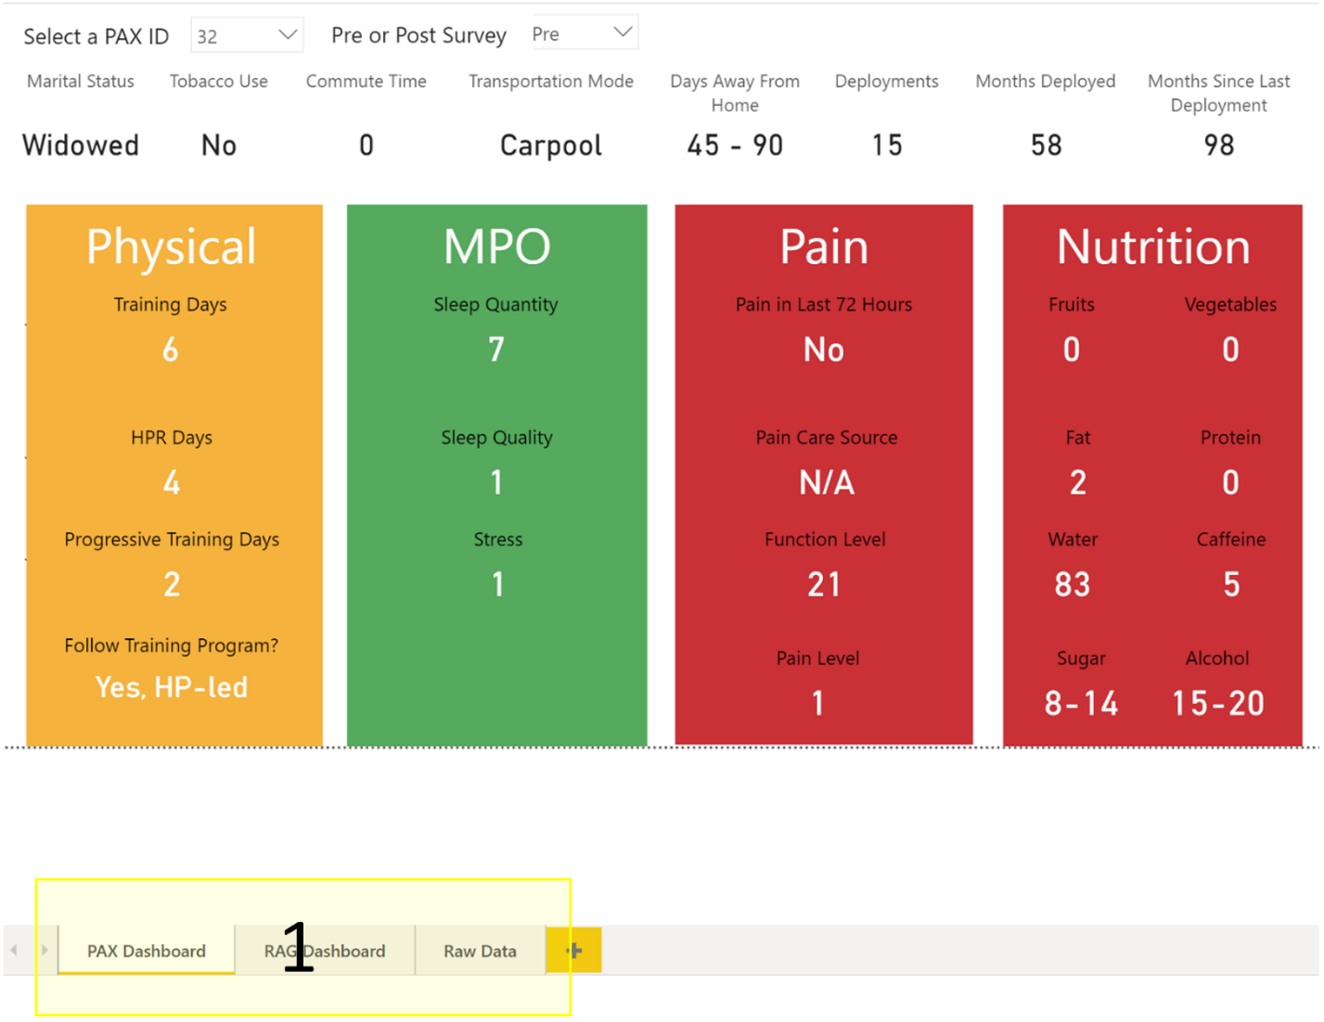

1

**Tab 1: PAX Dashboard**

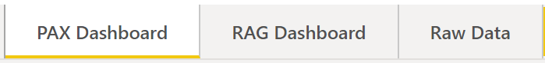

The first tab visualizes a single participant’s survey responses. To view a particular survey result, choose a PAX ID and Pre/Post survey at the top of the page [2].

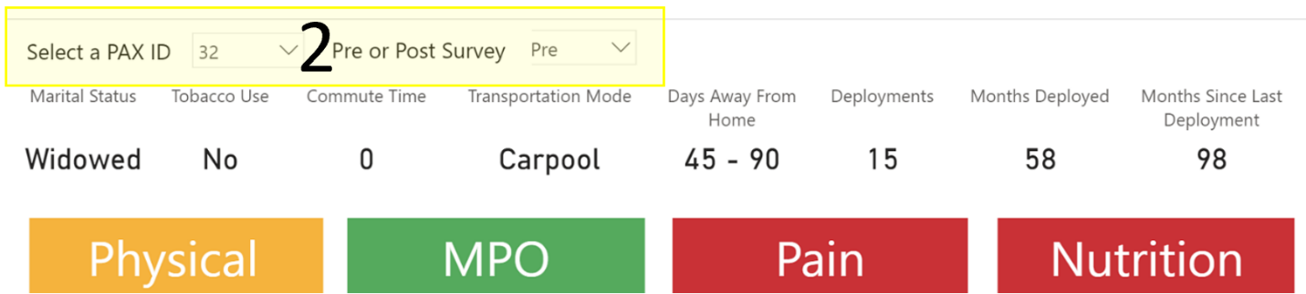

The row directly below the dropdown buttons, with a white background, is survey responses that are not associated with a RAG score [3]. Below that, each RAG section is shown as a column with the associated survey responses within the column. The background color is set to the respective RAG score that is calculated from the survey responses. The background color changes dynamically with the dropdown selections.

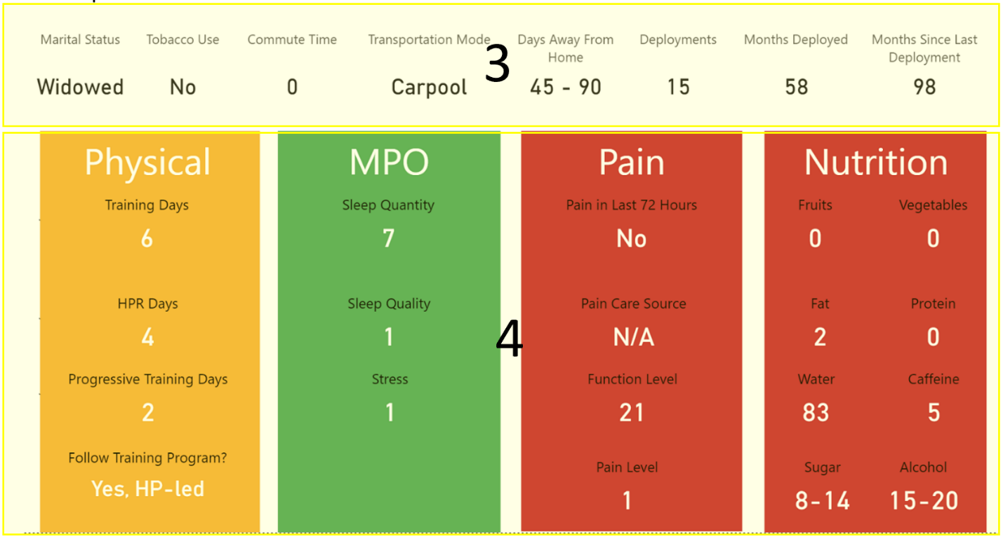

**Tab 2: RAG Dashboard**

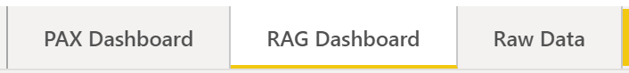

The second tab visualizes all RAG scores of every PAX ID to provide an at-a-glance summary. This visualization allows coaches to quickly determine and summarize which participants may need increased attention.

Choose whether to visualize Pre- or Post-survey results with the dropdown filter at the top of the page [5]. The first column of data lists each PAX ID. The “PAX ID” header can be clicked to change whether the data is sorted in ascending or descending order, indicated by the arrow underneath the header [6]. The four columns with headers “Physical”, “MPO”, “Pain”, and “Nutrition” contain the RAG scores for each PAX ID row.

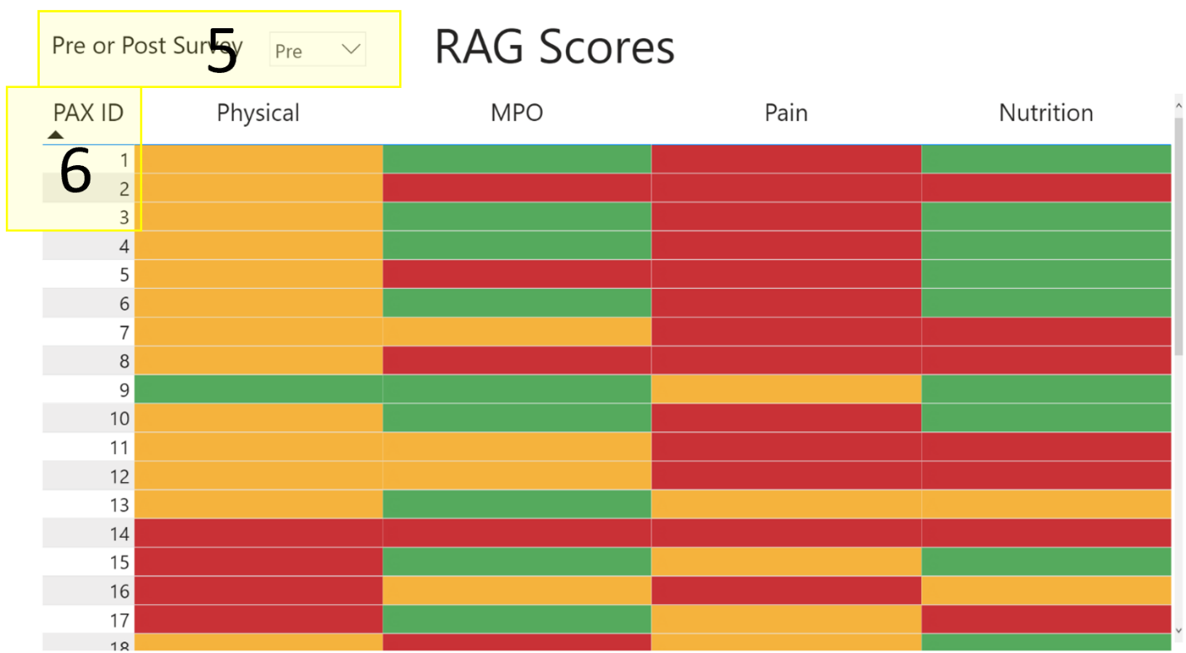

**Tab 3: Raw Data**

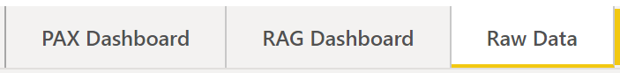

The third tab provides a summary table of all participants’ survey response data to provide access to the complete dataset in tabular form. Each column header corresponds to a PAX survey question in the order they are asked.

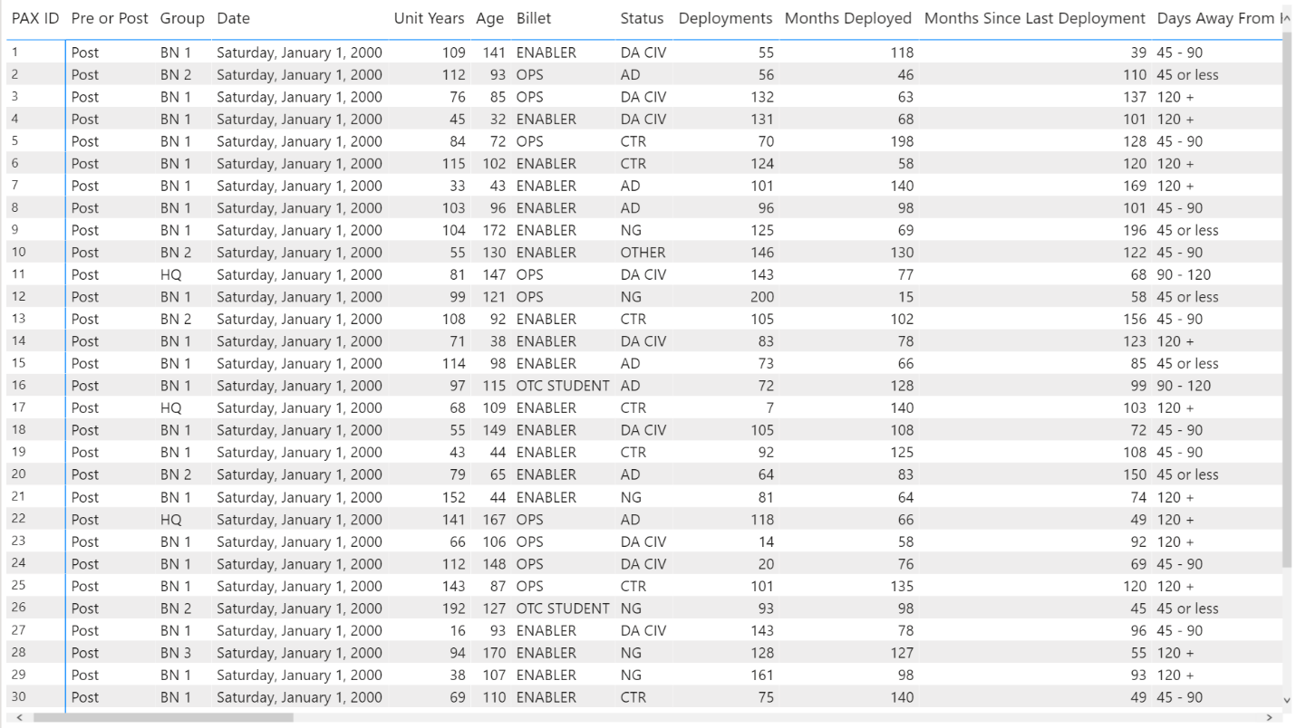

There are 4 added columns which display the calculated RAG score for each RAG section [7]. These columns are located immediate after the corresponding survey questions.

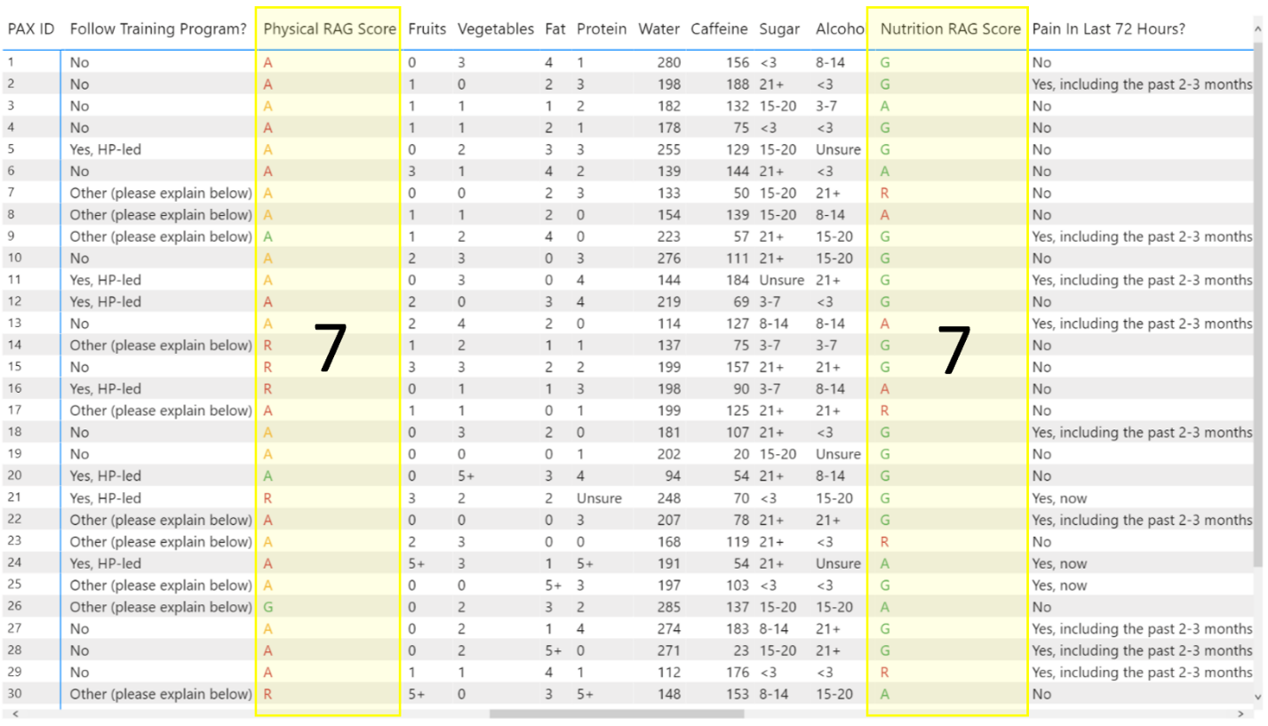

# **Scorecard**

## **Scope and Audience**

* Intended for program coaches and individual PAX participants
* Used to visualize participant results and scores for cognitive and physical tests at an individual and group level.
* All other database tables are also linked for further development, ex HRV and Sleep trends

## **Current Data Flow**

* Power BI updates to include new data after coaches complete PAX survey in Qualtrics and results are uploaded into database.
* Coaches open Power BI file and choose dashboard they wish to share with each PAX ID.
* A Names text file can be linked to allow for filtering by classified name instead of PAX ID.
* Scoring Benchmark and Goals for Cognitive and Body Comp were provided by the coaches and were manually entered in the Power BI data tables.
* Scoring Benchmark (70 points) and Goals (100 points) for ACFT Physical tests are linked to the PDF downloaded from here:  
  [fy20_standards.pdf (army.mil)](https://www.army.mil/e2/downloads/rv7/acft/fy20_standards.pdf)
  + This will need to be relinked by the DS team. If the standards change, they should be able to relink a new fy2X_standards file that will pull the new standards from the pdf and transform the data on the necessary ACFT Time and Amount tables.

**Key Data Transformations:**

1. Separating by Data type
   1. The physical data is split into the necessary data type to correctly compare to the scores. This created two physical tables, one with regular integers for scoring amounts and one based on time and scoring duration.
   2. The cognitive and inbody did not require transformations but have their own separate scoring system.
   3. All four different data types and scoring information are compiled in the calculated Summary table to aggregate the data to visualize all categories together in the bar charts.
2. Time Values:
   1. 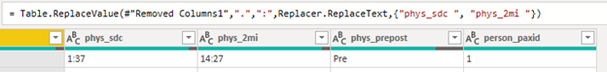Time is entered into the survey and database in mm.ss format. Both the phys_sdc and phys_2mi columns need to be transformed in order to be used as a Duration data type in Power BI. The phys_2mi example is shown below, a 5 step processes bookended with screenshots.

= Table.AddColumn(#"Replaced Value", "SDC fix", each "0.00:0")

= Table.AddColumn(#"Added Custom", "Merged", each Text.Combine({[SDC fix], [#"phys_sdc"]}, ""), type text)

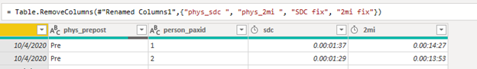= Table.TransformColumnTypes(#"Inserted Merged Column",{{"Merged", type duration}, {"phys_date", type date}})

**Key Columns/Measures:**

1. All tables (both physical tables, cognitive and inbody) have calculated columns to reference and calculate relevant information the following for each line:
   1. Score
   2. Benchmark
   3. Goal
   4. % to Benchmark
   5. % to Goal
   6. Met Benchmark
2. All tables have unique measures to calculate the following for individuals and group:
   1. Result - Latest PAX ID Results
   2. Min
   3. Avg
   4. Max
   5. Rank

**Tab 1:**

1. Added a menu tab to help with navigation if more scorecards are added for additional analysis.

**Tab 2:**

1. Individual Scorecard
   1. Changed the radial chart to a bar graph to help visualize performance against the benchmark (white tick marks)
   2. 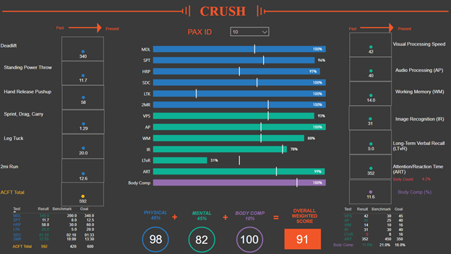Added in weighted average detail to describe the Overall Weighted Score

**Tab 3:**

1. Group Scorecard
   1. Keeping the same Individual PAX ID bar chart, but now comparing against Group and Overall averages for the tick marks
   2. Columns on the left compare an Individual within their Group and the columns on the right are to all participants to determine where the individual ranks and group level descriptive statistics
      1. Body Comp only shows the rank for now to protect that information but other descriptives could be added in.

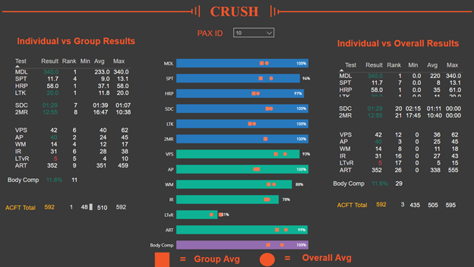

**Tab 4:**

1. HRV Analysis
   1. Possible additional tab to show trends of HRV or Sleep over time
   2. Measures have been added to calculate Z-Scores and Min-Max normalized values of Sleeps Hrs, Sleep Quantity and HRV data.

